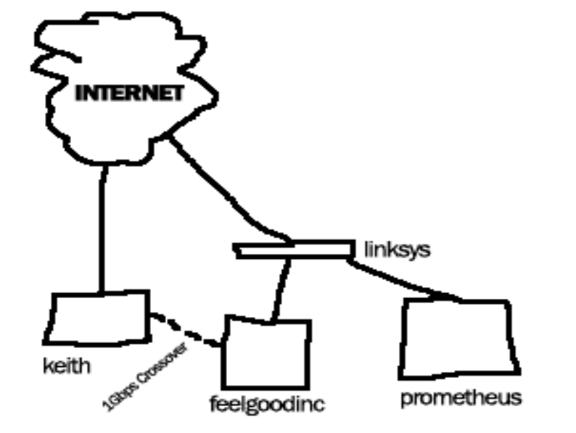

Entrypoints
- Internet-facing interface on keith
- Internet interface on linksys

This network is secure. keith’s Internet-facing interface has all through traffic blocked, and there is only one thing publicly running to the Internet – Line Printer Daemon. I use this to share my printer over the Internet. Since it requires that Print Services for UNIX be installed, it’s obscure enough not to be messed with (standard Windows printing doesn’t offer any more or less security). The linksys computer only acts as a NAT device and provides port forwarding for only a small number of ports.

